TOWNSHIP OF PIATT

ORDINANCE No. 2024-01

AN ORDINANCE OF THE TOWNSHIP OF PIATT, LYCOMING COUNTY, PENNSYLVANIA AMENDING THE PIATT TOWNSHIP

ZONING ORDINANCE OF 2021 TO DESIGNATE THOSE USES

NOT PROVIDED FOR IN THE PIATT TOWNSHIP ZONING ORDINANCE AS CONDITIONAL USES.

BE IT ENACTED AND ORDAINED by the Supervisors of Piatt Township, Lycoming County, Pennsylvania ("Township") and it is hereby ENACTED and ORDAINED by the authority of the same as follows :

SECTION 1: SHORT TITLE:

This Ordinance shall not be titled due to the fact that it is an amendment to the Piatt Township Zoning Ordinance of 2021 (No. 10.27.2021) .

SECTION 11: AUTHORITY :

This Ordinance is enacted pursuant to Section 1601 of the Second Class Township Code and Sections 10601 and 10609 of the General Municipal Law (53 P.S. SS 10601 and 1 C 609) .

SECTION 111: PURPOSE :

It is hereby declared that the enactment of this Ordinance is necessary for the protection, benefit and preservation of the health, safety and welfare of the general public, including, but not limited to, the residents of Piatt Township. This Ordinance provides for uses not otherwise provided for in the Piatt Township

Zoning Ordinance to be addressed as conditional uses.

SECTION IV: INCORPORATION OF EXISTING PROVISIONS:

Except as set forth below, the provisions of the Piatt Township Zoning Ordinance of 2021, as amended as of the enactment of this Ordinance, are incorporated herein and made a part hereof as though set forth in full.

SECTION V: AMENDMENT :

The Piatt Township Zoning Ordinance of 2021, as amended, is hereby amended as follows :

401 USES NOT PROVIDED FOR:

Whenever a use is neither specifically permitted or denied in any District in the Township, and an application is made by an Applicant to the Zoning Officer for said use, the Zoning Officer shall refer the application to the Township Supervisors to hear and decide such request as a conditional use. The Township Supervisors shall have the authority to permit the use or deny the use in accordance with the standards governing conditional use applications set forth in Section 1101 "Conditional Uses" of the

Township Zoning Ordinance. In addition, the use may only be permitted if:

1. It is similar to and compatible with the other uses permitted in the District where the subject property is located.
2. It is not permitted in any other District under the terms of the Township Zoning Ordinance.
3. It does not conflict with the general purposes of the Township Zoning Ordinance .

The burden of proof shall be upon the Applicant to demonstrate the proposed use meets the foregoing criteria and would not be detrimental to the public health, safety and welfare of the neighborhood where it is located.

SECTION VI: REPEALER:

Any Ordinance or parts of Ordinances which are inconsistent herewith are hereby repealed.

SECTION VI 1: SEVERABILITY :

T f any sentence, clause, section, or part of this Ordinance is for any reason found to be unconstitutional, illegal or invalid, such unconstitutionality, illegality or invalidity shall not affect or impair any of the remaining provisions, sentences, clauses, sections or parts of this Ordinance . It is hereby declared to be the intent of the Piatt Township Supervisors that this Ordinance would have

2

been adopted had such unconstitutional, illegal or invalid sentence, clause, section or part thereof not been included herein.

SECTION VI 11: EFFECTIVE DATE:

This Ordinance shall become effective five (5) days after the adoption hereof .

ENACTED and ORDAINED this G t h day of 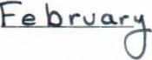1 2024 •

ATTEST : 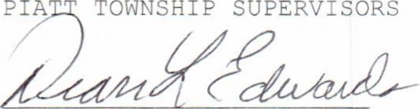

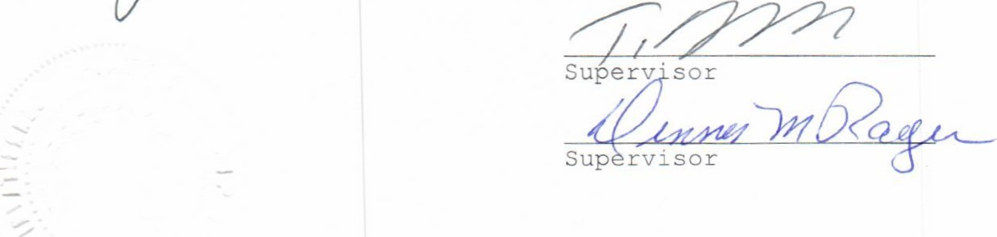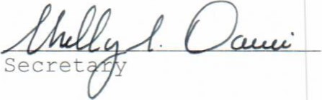 Supervisor

3